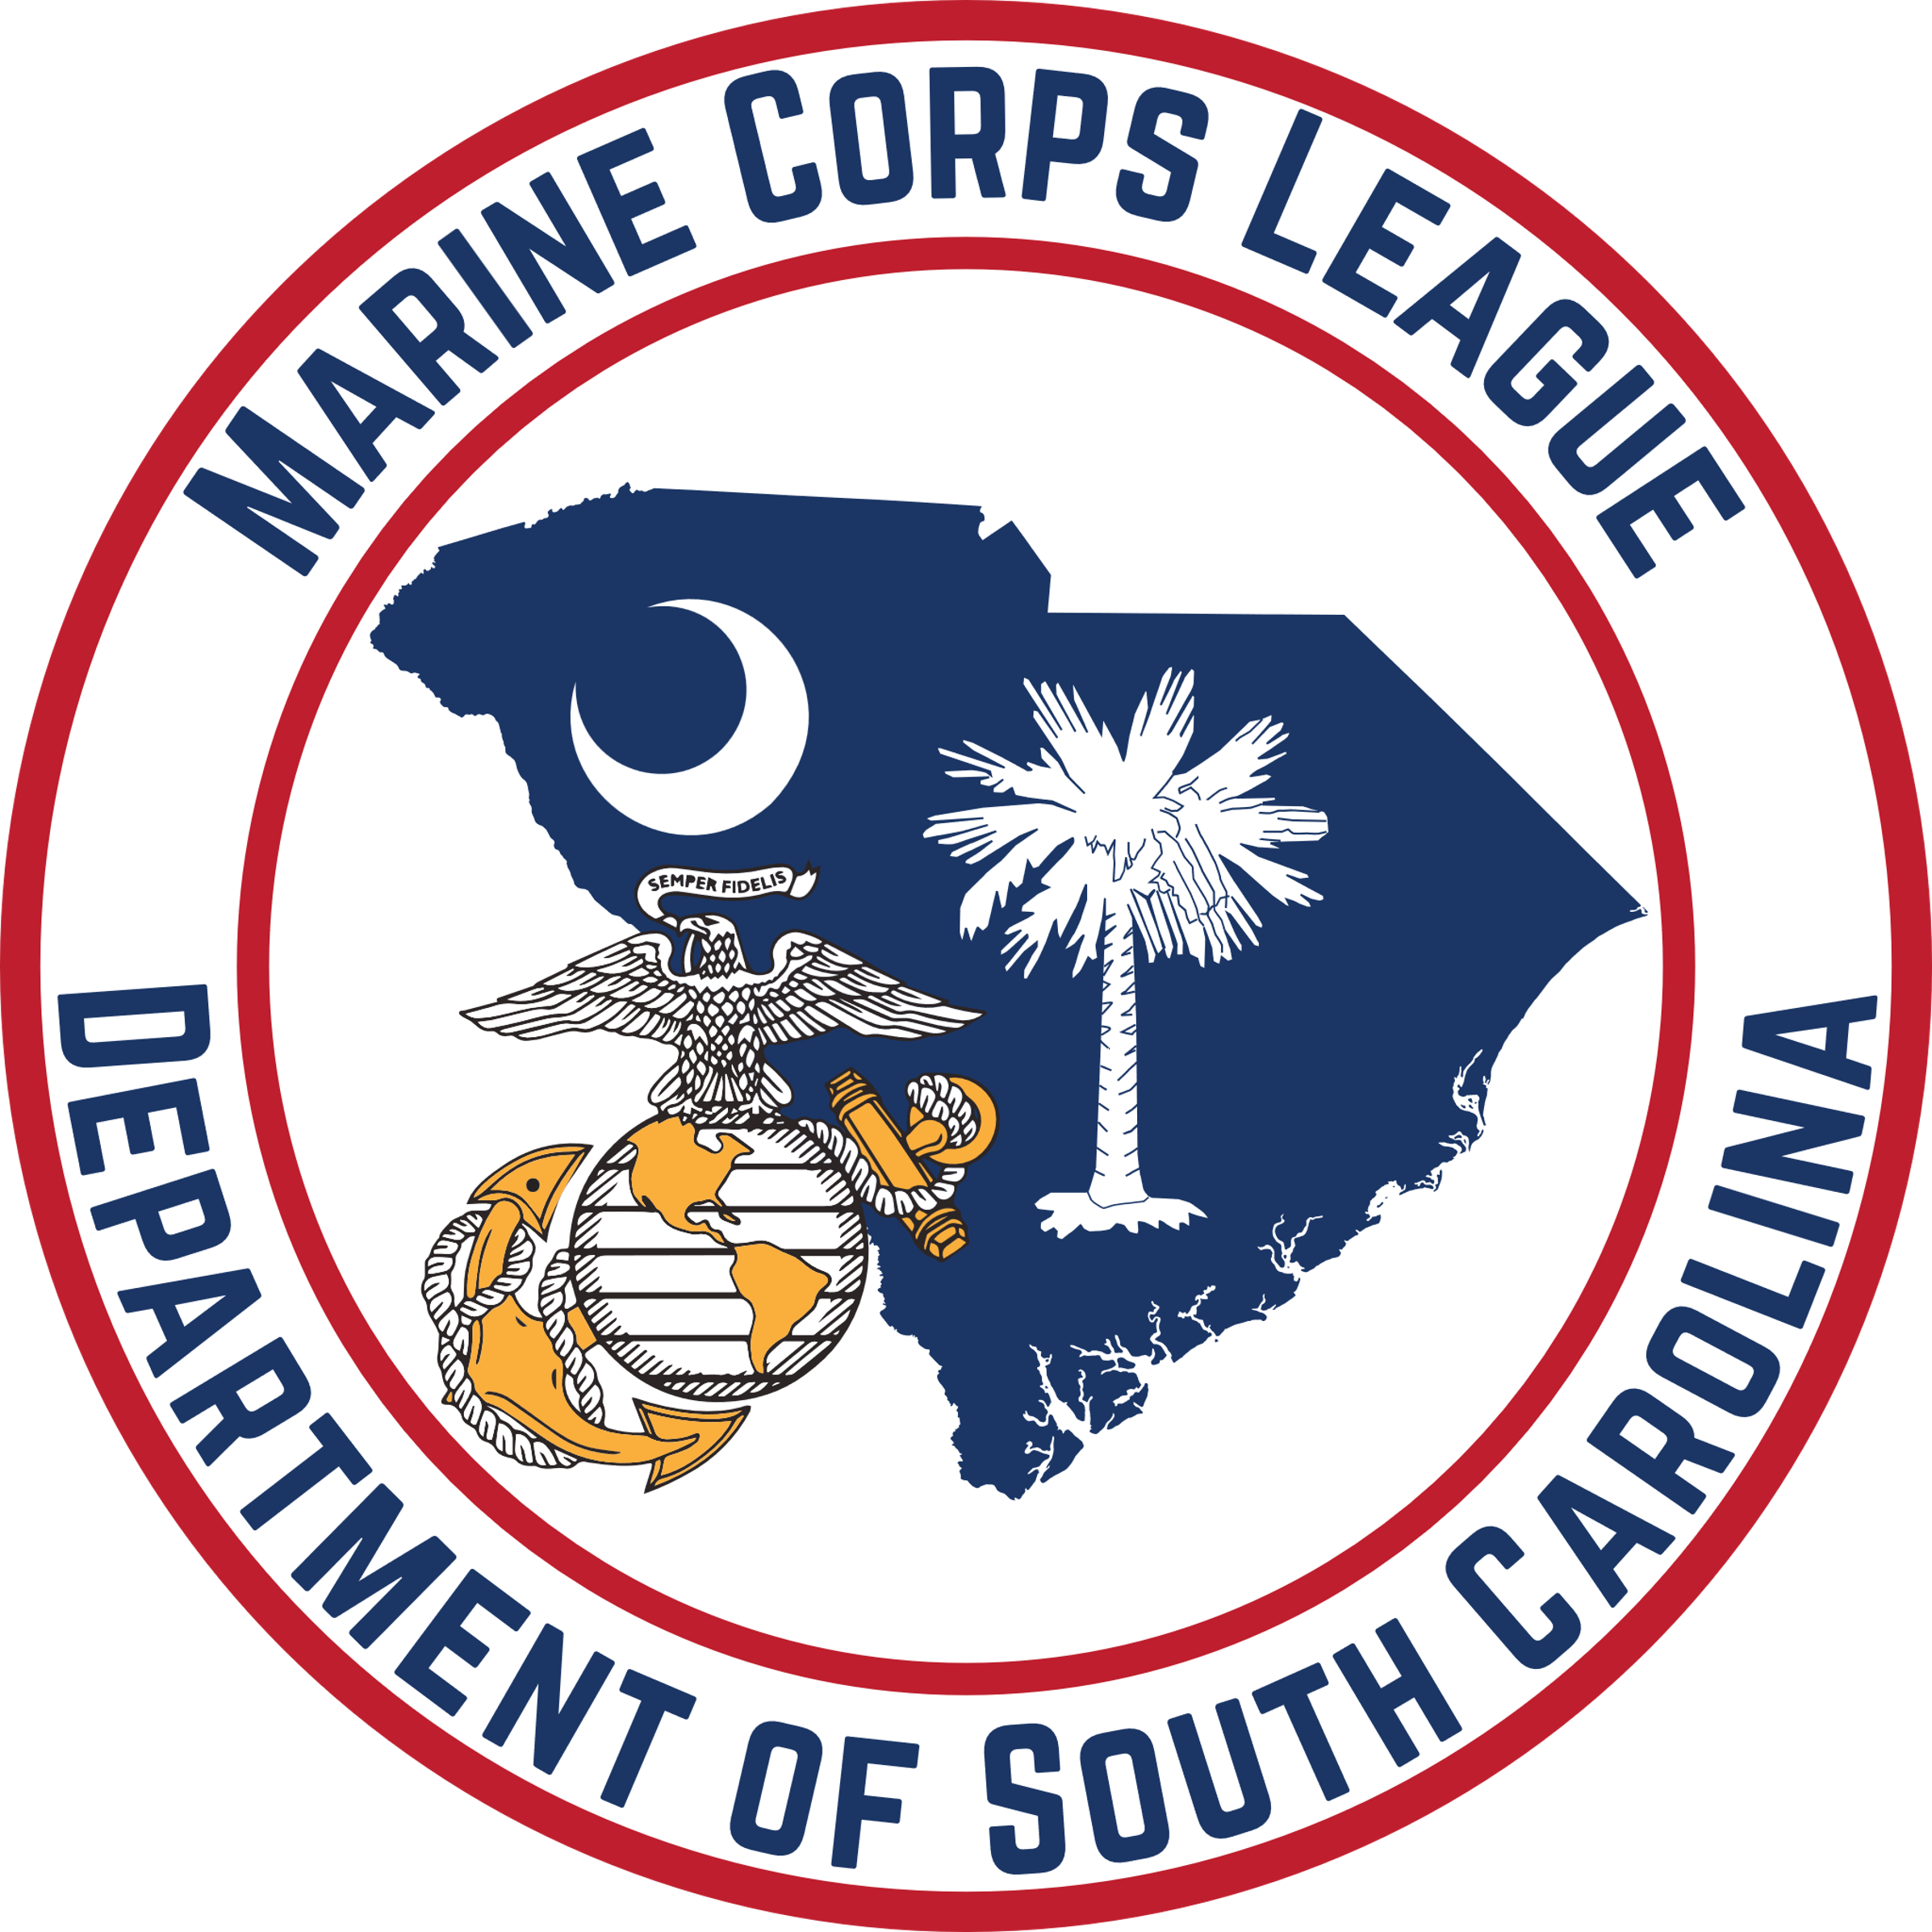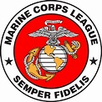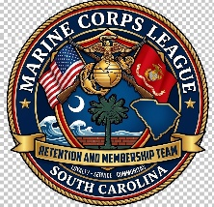

STRENGTHENING OUR RANKS:

A TRI-FOLD MISSION
Welcome to the inaugural edition of “Palmetto-Winds.” This newsletter is intended to share practical ideas and proven approaches for recruiting, retention, and marketing across our Department. I plan to publish it monthly and welcome your thoughts, examples, and recommendations for future issues.
During the National Convention, there was considerable discussion about the health of our beloved League and other Veteran Service Organizations. With annual dues due by 31 August, now is the time to focus not only on recruiting new members, but also on retaining those already brought into our ranks. Retention is essential to the continued strength and future of the League.
As we look ahead across the Department of South Carolina, our primary duty to the League remains clear: Recruiting, Retention, and Marketing are not three separate tasks—they are the vital pillars that support the long-term strength and vitality of our detachments.
Recruiting and retention are not optional—they are our shared responsibility. Strong detachments don't happen by accident; they are built through active leadership, member participation, and an unwavering commitment to our traditions and each other.

1. RECRUITING: "If You Don't Ask, You Don't Get"
Opportunities to recruit surround us every day—at local community festivals, veteran networks, gun shows, and casual everyday conversations. If we aren’t asking eligible Marines and FMF Corpsmen to join, we are missing the mission.
- Be Present in the Community: Set up informational tables at local events, parades, and veteran support functions.
- Provide Instant Access: Ensure your detachment has printed materials and modern digital tools, like QR codes, linking directly to state and national membership application portals.
- Make the Direct Call: Most prospective members simply haven't joined because no one extended the invitation. Take the initiative to ask.

2. RETENTION: "Giving Every Member Purpose"
Bringing a new member through the door is only half the battle; keeping them actively engaged is where true leadership shows. When new members join, we must get them involved immediately, give them purpose, and make them feel valued.
- Immediate Assignment: Assign new members a committee role or project that utilizes their unique military or civilian skill set right out of the gate.
- Conduct Personal Buddy Checks: Use annual roster audits and dues check-ins as an opportunity for personal outreach. A quick phone call from a Junior Vice Commandant or sponsor goes a long way toward re-engaging members who have missed recent meetings.
- Develop Tomorrow's Leaders: Encourage younger and newer members to step into committee and leadership roles. Testing fresh ideas ensures our organization stays vibrant and relevant.

3. MARKETING & OUTREACH: "Telling the Marine Corps League Story"
If our local communities don't know who we are or what we do, we lose out on prospective members, supporters, and community partners.
- Leverage Digital & Social Media: Regularly share photos and updates of your detachment’s service projects, Color Guard details, Toys for Tots drives, and scholarship presentations on web and social channels.
- Emphasize Our Core Impact: Highlight what the League stands for: preserving USMC traditions, supporting veterans in need, and serving communities across South Carolina.
- Engage Local Outlets: Submit press releases to local newspapers and community boards ahead of major events, military galas, and Marine Corps Birthday celebrations.
"Change and innovation are necessary for growth. By balancing our proudest traditions with forward-thinking outreach, we ensure the Marine Corps League remains strong, relevant, and thriving for generations to come."
Bottom line: Grow the League, Strengthen the League, and Stay Engaged.

Semper Fidelis!

