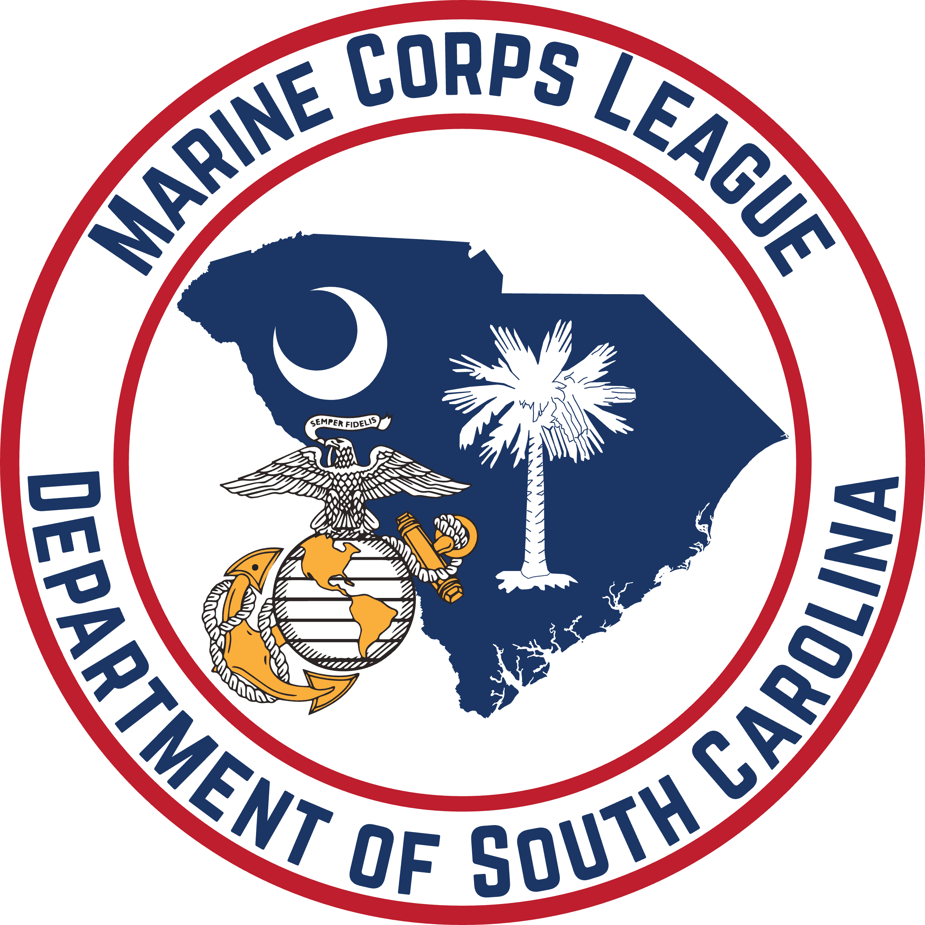

**DEPARTMENT OF SOUTH CAROLINA**

**2025 CONVENTION REGISTRATION**

**JUNE 19 - 22, 2025**

**Separate Registration form must be completed for each**

**MCL / MCLA / MODD member attending**

NAME: MEMBER ID:

*IF MODD Member* Degree / Pound Name & Number:   
CURRENT MCL / MCLA / MODD TITLE(S):

PREFERRED NAME ON NAME TAG:

MAILING ADDRESS:

CITY: STATE: ZIP:

EMAIL: PHONE:

MCL / MCLA / MODD UNIT NAME / NUMBER:

**(NON-MCL / MCLA)** GUEST(S):

PREFERRED NAME ON GUEST NAME TAG(S):

DATE OF ARRIVAL:

MCL REGISTRATION _____ @ $10 = $

MCLA REGISTRATION _____ @ $10 = $

MODD REGISTRATION _____ @ $10 = $

***IF ATTENDING GRAND GROWL ONLY***

BANQUET Saturday June 21, 2025

Buffet dinner with tea and coffee. Cash Bar will be available.

# of attendees _______ @ $65 = $_________

# of attendees _______ (***AFTER JUNE 1, 2025***) @ $70 = $_________

**TOTAL = $_________**

**MAKE CHECKS PAYABLE TO:**

DEPARTMENT OF SOUTH CAROLINA

**MAIL CHECKS TO:**

DEPARTMENT OF SOUTH CAROLINA CONVENTION

404 MOUNTAIN LAUREL CIRCLE

GOOSE CREEK SC 29445-7354