Department of South Carolina
Marine Corps League

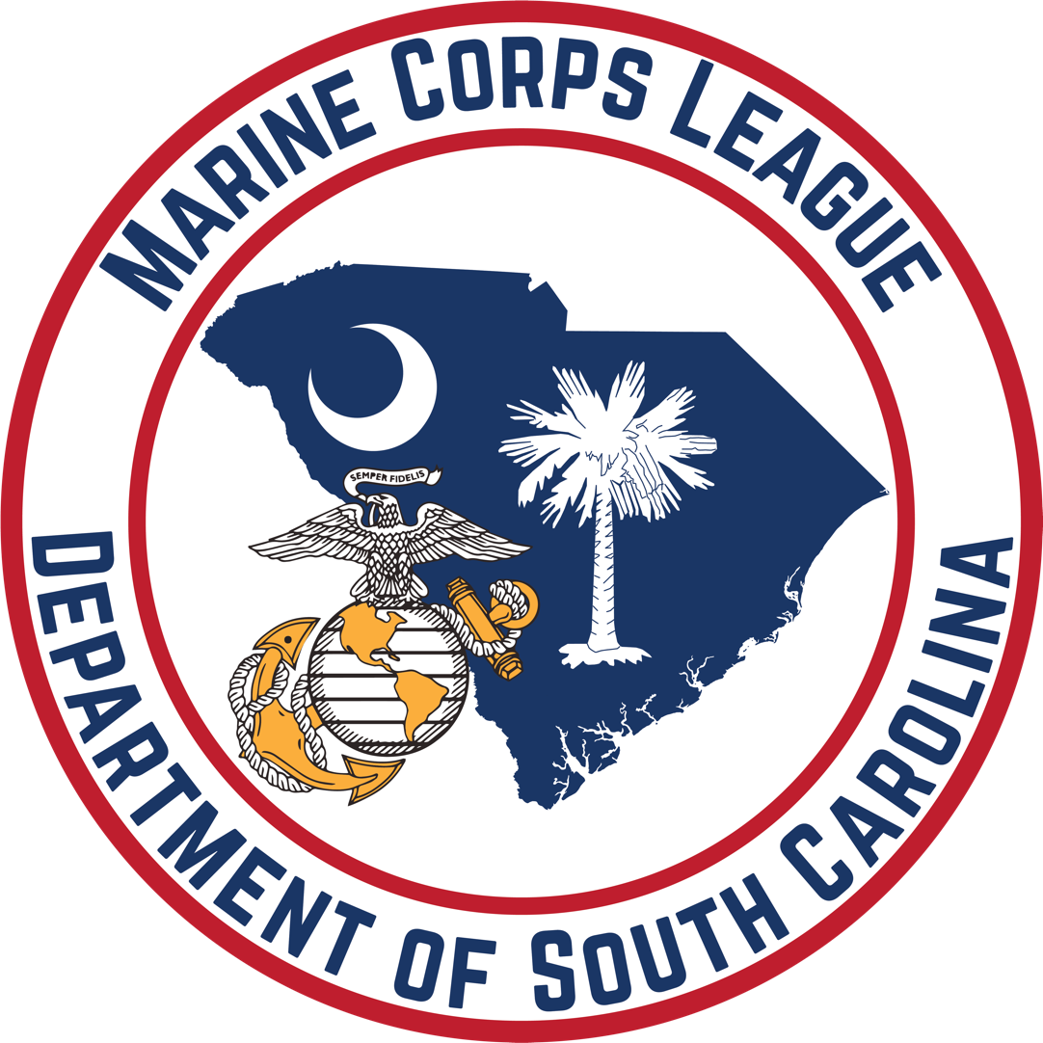

Marine of the Year /
Associate of the Year
Standard Operating Procedures
I. Purpose
This procedure sets procedures for selecting a Department Marine of the Year and Department Associate Member of the Year. The process ensures equal, fair and impartial guidelines for the nominees and selection.
II. Scope
The procedures and criteria contained herein are to be followed in the nomination, selection, and recognition process for the Department Marine of the and Department Associate of the Year (MOY and AMOY). It is the intent that these procedures shall be binding on all Department Officers, Detachment Commandants and all Detachment members.
III. Composition of Marine of the Year Committee (MOYC) and Associate of the Year Committee (AMOYC)
The Marine of the Year Committee will be a standing committee, reporting to the Sr. Vice Commandant.
- Chairman, MOYC / AMOYC
The Chairman of the MOYC / AMOYC shall be the most recent recipient of the Department MOY. The Chairman of the MOY Committee shall also oversee the Associate Member of the Year Committee.
- Committee Members, MOY Committee
    - Committee Members shall be comprised of previous recipients of the Department Marine of the Year Award in attendance at the Department Annual Convention.
  - The committee quorum will be three (3) members including the Chairman.
  - If there are not at least three (3) recipients present, the Commandant will appoint additional members to ensure that there are at least five members on the selection committee. Appointments will be considered in the following order:
          - Recipient of the Southeast Division Marine of the Year Award
          - Recipient of the Detachment Marine of the Year award.
          - Marine of the Year recipients from Southeast Division Departments in attendance at the Department Annual Convention.
          - National and Department Officers present.
  - Should a Department MOY recipient from another Department transfer membership to the Department of South Carolina, they can be asked to join the MOY Committee.

- Committee, Associate Member of the Year
    - The Primary Committee Member of the MOYC shall be the most recent recipient of the Department AMOY present at the Department Annual Convention.
    - The remaining Committee Members shall be comprised of previous winners of the Department Associate Member of the Year Award in attendance at the Department’s Annual Convention.
    - The committee quorum will be three (3) members including the Chairman.
    - If there are not at least three (3) past AMOY recipients present, members of the Department Marine of the Year Committee shall fill the remaining seats.
    - Should a Department AMOY recipient from another Department transfer membership to the Department of South Carolina, they can be asked to join the AMOY Committee.

IV. Nominations for Marine of the Year and Associate Member of the Year
- Only one nomination each for Marine of the Year and Associate of the Year may be made per Detachment annually.
- Nomination must be submitted by the nominee’s Detachment Commandant and sent to the MOY Chairperson by email with the subject line <YEAR> MOY (or AMOY) Nomination. The email address for the nomination submissions is DeptofSCMOY@gmail.com. The MOY Chairperson will be responsible for confirming receipt of each email submission received.
- Nomination documents must be sent as an attachment to the email, not included in the main body of the email.
- The nomination submission(s) must affirm that the submission was approved by a majority vote of members of the respective Detachment’s Marine / Associate Member of the Year Committee or by the Detachment, should the Detachment not have a MOY / AMOY Committee.
- The period of consideration for the Award shall focus on the member’s activities during the previous calendar year (1 January through 31 December) but longer periods may be used as supplemental information to show continuity.
- Emailed nominations must be electronically postmarked no later than
midnight EDT, thirty (30) days before the Department Annual Convention of the current year. Nominations failing to meet the time requirement are ineligible and will not be considered.
- The nominee must be a regular member in good standing in a Detachment within the Department of South Carolina.
- If the nominee is the Detachment Commandant, the Nomination will be endorsed by the Detachment Senior Vice Commandant.
- The Department Marine of the Year shall be awarded only once per recipient.
- The Department Associate Member of the Year may be awarded to a recipient twice, provided there are five years between the awards.

V. Nomination Submissions
- The nomination cover sheet should include the following information: the name of the nominee, the Detachment name and number. The nominating letter MUST be typewritten and submitted as an attachment to the submission email, NOT included in the body of the email. The nomination letter should refrain from using the name of the Detachment and the name of the nominee to keep nominees anonymous. (see Attachment “A” for an example).
- Submissions should include, but not be limited to, offices held within the League, involvement in Detachment / Department operations (meeting attendance, etc.), volunteer work on Detachment / Department projects, fundraising activities, community activities, civic activities, social activities, etc. See Attachment (1) for a sample nomination letter.
VI. Scoring
The scoring process will be the same for both Marine of the Year and Associate Member of the Year.
- Within fourteen (14) days of the submission deadline, the Chairman shall separate the nomination cover sheet and assign each nominee a number, which will be listed on a scoring sheet.
- Electronic copies of each nomination received, and an Official Scoring Sheet with all nominees listed; will be emailed to all Past Department MOY / AMOY recipients no later than fourteen (14) days before the opening date of the annual Convention for review.
- Nominations will be ranked by the Chairman and each member.
- The Chairman and each Committee Member will rank nominations from first to last on the Official Score Sheet. The best nomination will receive a value of 1, the next best nomination will receive a value of 2 and so on, until all nominations have a value.
- Completed scoresheets must be signed and will be submitted at the scheduled MOY Selection Committee Meeting at the Department Convention. Should the Chairman not be present at the Department Annual Convention, the next most recent recipient will oversee the voting.
- The CMOYC and at least two additional members will total the scores and announce the results. The nomination with the lowest total values will be declared the winner.
- Should a tie occur, the Chairman and Committee Members will re-score the tying nominations only. A value of 1 or 2 (and 3 if there is a three-way runoff) will be given to the tying nominations by the Chairman and Committee Members. The Chairman and at least two additional members will total the scores. The nomination with the lowest total will be declared the winner. This process will continue until a winner is determined.
- All voting and tiebreakers shall only be held in person by the Committee members in attendance at the Department Annual Convention.

V. Awarding of MOY / AMOY Medallion
- The announcement and awarding of the of the Marine of the Year and Associate Member of the Year will be done annually at the Department Annual Convention Banquet by the MOY / AMOY Committee.
- All nominees will be individually recognized before the announcement of the winner.
- Recipients of the MOY / AMOY Award shall be presented a MOY / AMOY Medallion at the Banquet. Recipients will be presented a plaque no later than the following year’s Annual Convention.
- Medallions and Plaques will be acquired by the Sr. Vice Commandant and given to the Committee before presentation at the Annual Convention Banquet.

VI. List of Annual Marines of the Year / Associate Members of the Year.
- A list of previous recipients will be maintained and updated annually by the MOY Committee.
- The list of annual MOY and AMOY Recipients will be printed in the Convention Program Book each year.

VII. Amendments to MOY / AMOY SOP
Department Marine of the Year / Associate Member of the Year SOP will be reviewed by MOY Committee and proposed amendments from the MOY Committee will be submitted to the Sr. Vice Commandant and voted on by the Board of Trustees no later than the first Department Quarterly Meeting of each year to allow for announcement of any changes for that year’s Nomination / Award process.

Attachment A – Sample Nomination Submission
Page 1:
Nomination Cover Sheet:
Nominee: Chesty Puller
Detachment Name & Number: Podunk Marines, Detachment #412
City & State: Anytown, SC
I certify that this nomination was unanimously voted upon by the members of our Detachment / Detachment’s Marine of the Year Committee.
Detachment Commandant Printed Name
(Sr. Vice Commandant if nominee is Commandant)
Nomination Number (For Chairperson Use) ____________
Page 2:
Our Detachment is proud to nominate this Marine for Department of South Carolina Marine of the Year.
This Marine has exemplified the meaning of selfless service. In October, this Marine saved the life of an elderly man who had fallen, breaking bones and bleeding severely. Many people went past this man, not stopping to help. This Marine heard his cries, called 911 and rendered first aid until EMS arrive and took over. He followed up, visiting the family, bringing them meals afterward and kept up with the man until the man passed a few months later. The family expressed their gratitude to this Marine for giving their family a few more months with this beloved member of their family.
This Marine has traveled to several foreign countries to work in the mission field with his church. In Malpaisillo, Nicaragua, he helped dig the foundation of their new medical clinic, then ran electrical lines, established running water, and set up the internet and communication system between the staff and doctors. Recognizing that high blood sugar often goes untreated there, he taught the staff about diabetes and how to use the testing equipment. Due to the recent civil war, the clinic has been used as a school to educate the people of the tiny community so they can continue to learn to read and write. He is planning return trips to Nicaragua and Bogota, South America, to help further when travel restrictions are lifted.
This Marine is a volunteer and the Marine Corps League VAVS representative at the local VA hospital. While there he was the technical advisor to the artist who repainted the portrait of Marine PFC Ralph H. Johnson, for whom a Naval Ship and the Hospital is named, ensuring the uniform complied with USMC regulations, as the previous portrait did not.
Drawing upon his 20-year VA employment, he assists other Veterans, answering questions about benefits and assists in providing VA Service Officers to initiate compensation claims for Veterans. He has volunteered for 11 years and encouraged others to volunteer for the annual VA Homeless Stand-down locally.
Currently, he is a committee member of a Veteran home repair non-profit, assisting in the assessment, planning, and reconstructing of needy veteran’s homes. He is currently assisting a 10-year disabled Army Veteran whose home needs a new foundation and floors.
Within the League, he currently serves as Detachment Adjutant and Department Sergeant-at-Arms after previously serving as Detachment Junior Vice and Commandant. As Commandant, he established a monthly and annual budget and reestablished the Detachment Scholarship program. He also serves as the Senior Vice Pound Keeper and Dog Trainer for his Devil Dog Pound and recently received his gold collar at the Supreme Growl. He added a bit of fun to aiding the local animal shelters with his project named “Operation Rescue” aka Ton of Fun, which has collected more than one ton of pet food and supplies within twelve months. He is also serving at the Department level.
He has participated in external, community-focused events sponsored by the Detachment, funeral and memorial services, and the Travis Manion Run. Always seeking new members, he recently recruited an FMF Corpsman and a Korean War Marine. The Korean War Veteran was unable to come to the Detachment meetings due to illness, but undeterred, this Marine and his wife sought support from the Detachment to hold a special installation event at his home, attended by Detachment members. This event was attended by more than 30 people and was featured on the local news station. His actions truly reflect the motto “No Marine Left Behind”.
It is for this and many more reasons that our Detachment nominates this Marine as Department Marine of the Year.

