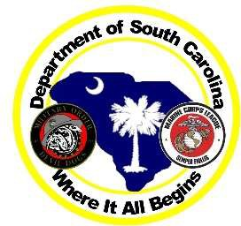
MARINE CORPS LEAGUE
DEPARTMENT OF SOUTH CAROLINA 2020 CONVENTION September 9-12, 2021

Activities and Banquet Registration

Hilton Greenville ~ 45 W Orchard Park Dr. ~ Greenville, SC 29615 ~ 864-232-4747

Name: Name: Title: Title/Spouse: Det/Unit: Det/Unit: Street Address: Street Address: City/State/Zip: City/State/Zip: Phone: Phone: Email: Email: A program book will be printed. All units of the MCL, MCLA and MODD are all encouraged to support the program book to help offset the cost of the Conference. Ad submission deadline 7/31/21. Program books will be given to paid attendees only that register before July 31, 2021.

A $10.00 Registration fee is required for all members of the Marine Corps League. Spouses who attend do not pay a fee. Check with your Detachment Commandant, some detachments pay this fee.
# of registration fees ____________________

AD Book Full Page @ $100 _
Half Page @ $50_
Quarter Page @ $25

Business Card @ $10 _
Patron Name @ $2.00
Ad Journal Total $_

Friday Night BBQ Dinner with Band 50-70’s music Qty @$35.00 =

Pulled pork bbq (buffet style) w/ buns & assorted sauces, house salad w/ ranch & Italian dressings, Cole slaw, Baked beans, House chips. Chefs choice of dessert, Tea & water

Banquet @ $50.00 Quantity Banquet Total $
Banquet deadline is August 10, 2021
Buffet style-Chef’s choice chicken, fish and Bistro tenderloin, House salad with ranch and Italian dressings, Seasonal vegetables, Mashed or roasted potatoes, Chef’s choice of dessert, Vegetarian plate on request, tea, water, and coffee
Total Due____________

CK/mo #_________ Credit/Debit card #_________________ Exp date CV

Name on Card ________________________________Zip code _Amount to be charged ____

Please make checks and money orders payable to MCL Det 1105 Convention 2021. Please mail to: Deborah Stone, 9 Azure Lane, Greer, SC 29651.

Date Rec’d. | Email Confirmation | Name tag

Banquet/Activities Registration Rev 11 4/15/21

